Kaggle Dataset Link: https://www.kaggle.com/datasets/balabaskar/wonders-of-the-world-image-classification
Screenshots of the application output:
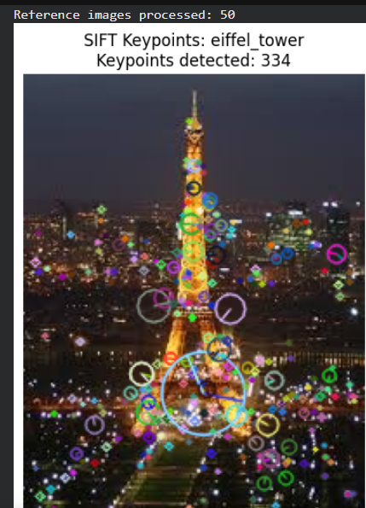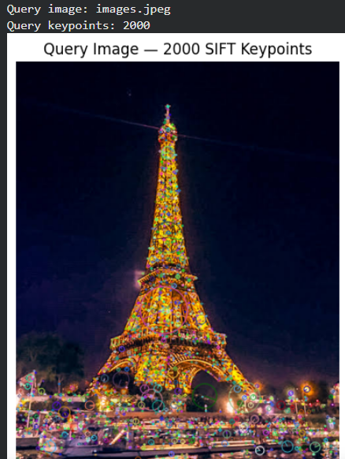

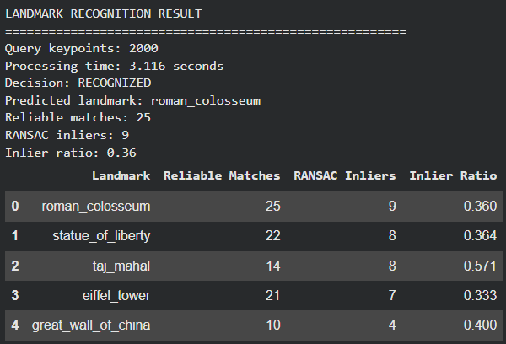
Table of Experimental Results:

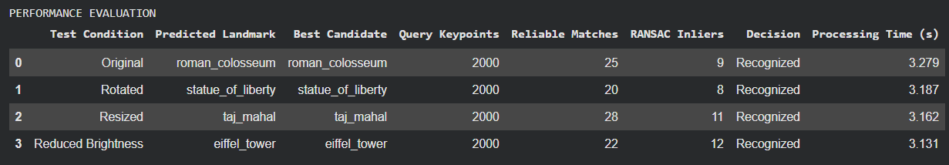

Performance Discussion:
The SIFT based landmark recognition system identifies landmarks by detecting key points and matching their feature descriptors with reference images. The system uses Brute Force Matching, KNN, and Lowe’s ratio test to find reliable matches. Homographs and RANSAC are used to verify the matches and locate the landmark in the query image.
The system can recognize landmarks when images are resized, rotated, or have reduced brightness, provided that enough reliable features remain. RANSAC improves reliability by removing incorrect geometric matches. The experimental results help evaluate the recognition decision, number of key points, reliable matches, RANSAC inliers, and processing time.
Limitations:
- Image quality: Blurry or low-resolution images may produce fewer keypoints and unreliable matches.
- Lighting conditions: Very dark or overexposed images can reduce recognition accuracy.
- Different viewpoints: Major changes in camera angle may make matching difficult.
- Similar landmarks: Buildings with similar shapes or textures may produce incorrect matches.
- Processing time: Comparing a query image with many reference images can increase processing time.
- Unknown landmarks: The system may reject an unknown landmark, but it can still make an incorrect prediction if the image produces enough misleading matches.
Conclusion:
The experiment demonstrates that SIFT-based feature matching can be used for landmark recognition without training a deep-learning model. The combination of feature matching and RANSAC helps improve the reliability of recognition and supports landmark localization. However, the system's actual performance depends on image quality, reference image diversity, and the selected matching thresholds. More testing is required to determine its accuracy under different conditions.

